Endpoint Attack Detection & Investigation Lab

Microsoft Sentinel + Sysmon + Windows Endpoint

Project Goal: Build an endpoint detection lab that demonstrates host telemetry collection, SIEM ingestion, threat hunting, and alert engineering using Microsoft Sentinel.

1) Executive Summary
This project simulates a modern SOC workflow by forwarding Sysmon endpoint telemetry from a Windows virtual machine into Microsoft Sentinel through a Log Analytics Workspace. The lab focuses on detecting attacker tradecraft at the endpoint level, beginning with suspicious Base64-encoded PowerShell execution, then expanding into persistence and post-exploitation detections.

2) Lab Architecture

Components
- Windows VM: JozefsVM
- Telemetry Agent: Azure Monitor Agent
- Endpoint Logging: Sysmon
- SIEM: Microsoft Sentinel
- Workspace: JB-LAW
- Log Source: Microsoft-Windows-Sysmon/Operational

Data Flow
- Attack activity occurs on the Windows endpoint
- Sysmon captures process creation events
- Azure Monitor Agent forwards logs via DCR
- Logs land in Log Analytics workspace
- Microsoft Sentinel queries generate detections
- Alerts are converted into incidents for investigation

3) Telemetry Enablement

Sysmon Deployment
Sysmon was deployed directly on JozefsVM using the Microsoft Sys-Internals Sysmon64 binary and the SwiftOnSecurity Sysmon configuration to provide enterprise-style endpoint telemetry.
Installation steps executed on the VM:
mkdir C:\Tools\Sysmon
cd C:\Tools\Sysmon
Invoke-WebRequest -Uri https://download.sysinternals.com/files/Sysmon.zip -OutFile Sysmon.zip
Expand-Archive .\Sysmon.zip -DestinationPath C:\Tools\Sysmon -Force
Invoke-WebRequest -Uri https://raw.githubusercontent.com/SwiftOnSecurity/sysmon-config/master/sysmonconfig-export.xml -OutFile sysmonconfig.xml
.\Sysmon64.exe -accepteula -i .\sysmonconfig.xmlValidation
After installation, Sysmon service health and event generation were verified by confirming:
- Service: Sysmon64 running
- Log Channel: Microsoft-Windows-Sysmon/Operational
- Primary Event Used: Event ID 1 (Process Creation)
This telemetry source later became the primary log feed for Sentinel threat hunting and scheduled alert generation.
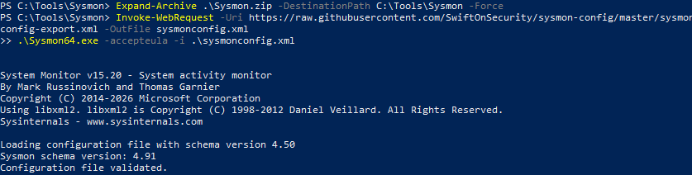

Data Collection Rule (DCR)

A Data Collection Rule was configured to forward Sysmon operational logs from JozefsVM into the JB-LAW Log Analytics workspace.
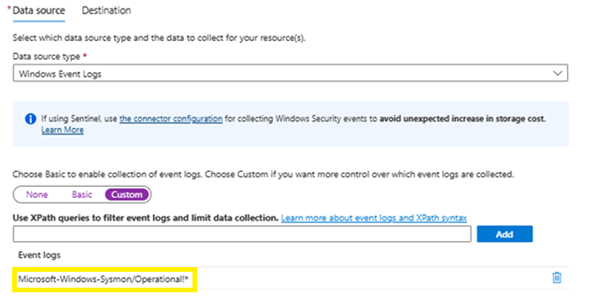
Telemetry was sourced from Microsoft-Windows-Sysmon/Operational because Sysmon provides enhanced process creation visibility, including full PowerShell command-line logging required for encoded execution detection.
Configuration
- Target VM: JozefsVM
- Data source: Windows Event Logs
- Channel: Microsoft-Windows-Sysmon/Operational
- Destination: JB-LAW
- Agent: Azure Monitor Agent

Purpose
This configuration establishes persistent endpoint log ingestion into Microsoft Sentinel, providing the telemetry foundation required for threat hunting, analytic rule development, alert validation, and post-detection investigation.

4) Initial Threat Hunt — Encoded PowerShell

Objective
Detect suspicious PowerShell executions using the -enc flag, a common obfuscation technique used by attackers.

Hunting Query

Event
| where Source == "Microsoft-Windows-Sysmon"
| where EventID == 1
| where RenderedDescription contains "-enc"

Detection Logic
This hunt focuses on identifying suspicious PowerShell execution patterns that may indicate attacker activity. The logic is designed to surface:
- Encoded commands using Base64
- Obfuscated or stealthy script execution
- Early-stage execution techniques associated with malicious tradecraft

MITRE ATT&CK Mapping
- TA0002 — Execution
- T1059.001 — PowerShell

Attack Simulation
To validate the detection logic, an encoded PowerShell command was executed directly on JozefsVM. This emulated adversary tradecraft by leveraging obfuscated PowerShell execution, a technique frequently used by threat actors to bypass basic security controls, obscure payload visibility, and execute malicious code during the initial stages of compromise.
Attack Simulation on Endpoint
Test Command:
powershell -nop -w hidden -enc SQBmACgAJABQAFMAVgB1AHIAcwBpAG8AbgBUAGEAYgBsAGUALgBQAFMAVgB1AHIAcwBpAG8AbgApAA==
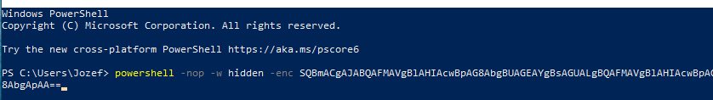
Purpose:
This simulated adversary tradecraft using Base64-encoded PowerShell execution, a common technique used for:
- malware staging
- defense evasion
- payload execution
Detection Result:
This execution successfully generated a Sysmon Event ID 1 process creation log and was detected by the Sentinel KQL hunting query. 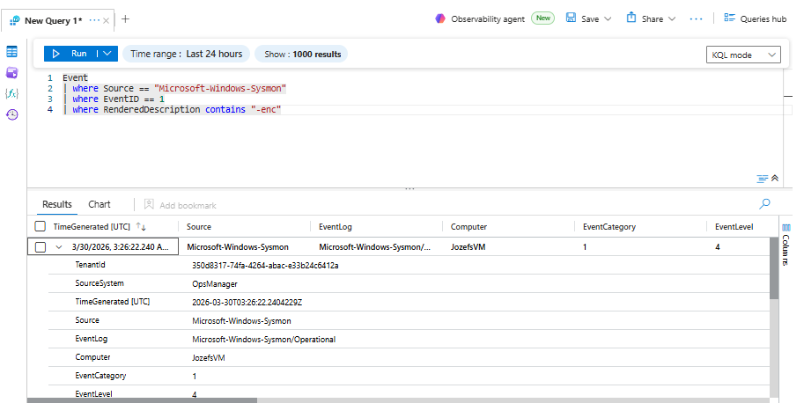

5) Scheduled Analytics Rule Deployment
After validating the hunting query, the detection logic was operationalized as a Scheduled Analytics Rule in Microsoft Sentinel.
Rule Configuration
- Rule Name: POWERSHELL EX
- Rule Type: Scheduled query rule
- Data Source: Microsoft-Windows-Sysmon/Operational
- Event ID: 1
- Detection Condition: Command line contains -enc
- Severity: High
- Tactics: Execution, Defense Evasion
- Techniques:
  - T1059.001 — PowerShell

Detection Query
Event
| where TimeGenerated > ago(2h)
| where Source == "Microsoft-Windows-Sysmon"
| where EventID == 1
| where RenderedDescription contains "-enc"
| project TimeGenerated, Computer, RenderedDescription
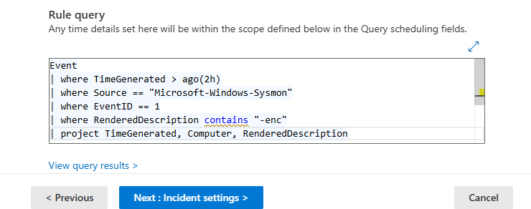

Endpoint Validation Script Execution
To validate the scheduled analytics rule, a benign encoded PowerShell script was executed directly on JozefsVM.
The purpose of this step was to simulate obfuscated PowerShell execution behavior commonly observed during malware staging, payload launch, and post-exploitation scripting.

Validation Script Executed on VM
$cmd = 'Write-Output "Sentinel test"'
$enc = [Convert]::ToBase64String([Text.Encoding]::Unicode.GetBytes($cmd))
powershell.exe -enc $enc
Execution Purpose

This script safely:
- Generates a benign PowerShell command
- Encodes the command in Base64 Unicode
- Executes the payload using the -enc switch
- Triggers Sysmon Event ID 1
- Validates the Scheduled Analytics Rule
- Generates a High-severity alert in the unified Defender incident queue

Expected Detection Outcome
After execution, Microsoft Sentinel successfully matched the process creation telemetry against the scheduled rule logic and generated a High-severity alert tied to JozefsVM.
This confirmed:
- endpoint telemetry visibility
- KQL rule logic
- scheduled alert generation
- Defender unified incident correlation

Operational Outcome
The rule successfully generated a High-severity alert which was automatically correlated into the Microsoft Defender unified incident experience.

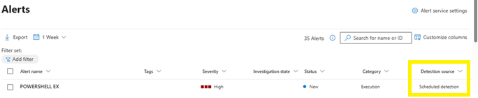

The resulting incident included:
- Endpoint: JozefsVM
- Sysmon process creation telemetry
- 4 grouped alerts
- Incident severity: High
- Incident status: New

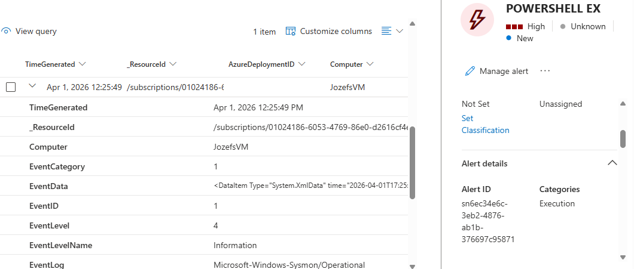

This validated the full pipeline from:
endpoint telemetry → SIEM detection → scheduled alert → unified SOC incident
This result validated the full production-style detection pipeline, proving that endpoint telemetry was successfully ingested, analyzed by scheduled Sentinel logic, converted into a high-severity alert, and escalated into a unified SOC incident for investigation.

Production Relevance & SOC Value
Encoded PowerShell is frequently used by adversaries for payload staging, in-memory execution, and defense evasion. This detection demonstrates how endpoint process telemetry can be transformed into actionable SOC alerts that reduce attacker dwell time and accelerate analyst triage.

